MEDIA RELEASE
EMBARGOED: 27TH March 2013

Teens missing out on healthy eating and meal-time education
according to new research from Australian Pineapples

Nutrition experts are urging families with teens to recognise the importance of family meal-time, as recent research shows only 37 per cent of families with teens are eating together on a daily basis, according to research from Australian Pineapples.

The research also found parents of 12-17 year olds are concerned about their children’s diets, with 64 per cent stating they want their children to eat more fruit.

The Australian Pineapples Family Nutrition Report, commissioned by the industry body for Australian Pineapple growers, surveyed 510 Aussie parents about their eating habits. The report focused on parental influence on family eating habits and behaviour around fresh fruit.

“The importance of family meal time is not only about the opportunity to provide a nutritional meal at the table, but instills healthy eating habits and social confidence for life,” says leading nutritionist and Australian Pineapples spokesperson, Dr Joanna McMillan.

“Teenagers are often busy with after school activities, social engagements, sports and study, but there needs to be an emphasis on family meal time to make sure they are getting the foods their body needs,” says Dr McMillan.

Dr McMillian sites recent studies show at least one in five Australian teenagers suffer from eating disorders stemmed from dieting.

“Teenagers are going through significant changes emotionally and physically, and are also extremely susceptible to eating disorders as they become aware of body image,” says Dr McMillan.

“Fresh fruits should be an integral part of a teen’s diet. Although it can be hard to get them to eat it straight from the bowl, being creative with dinners they love can make all the difference in their mental and physical wellbeing,” she says.

The report also showed that as well as missing out on family meal time, only one in three parents of teenagers provide fresh fruit for their children, daily.

Pineapple grower, Ben Clifton, says pineapples offer a variety of nutritional benefits, make a great snack and are available all year.

“Eating fresh pineapples needn’t be restricted to summer. They are readily available on shelves throughout the year and provide tonnes of health benefits to even the fussy eaters in the family,” says Clifton.

- MORE-

Australian Pineapples offers the following nutritional information for growing teens:

- Pineapples are a wonderful source of Manganese, which has been proven to help build and maintain strong bones and connective tissues. One cup of pineapple contains 73 per cent of your total daily requirement

- Aussies are encouraged to eat a diet high in Potassium to maintain a healthy heart rate and blood pressure. Fruits such as pineapples contain potassium and can help meet the recommended daily intake

- Pineapple is a good source of Bromelain, which works to keep the digestive track healthy

- Vitamin B6, also found in pineapples, is an essential vitamin that assists with the production of nerve cells, amino acids and neurotransmitters including serotonin and adrenalin to help support the body’s natural coping mechanisms

Dr Joanna McMillan suggests using fresh pineapple in classic recipes to get young adults eating the right foods.

“As the weather cools, curries such as this Pineapple, Sweet Chicken and Chilli Curry are sure to get even busy teens to the table at dinner time!” says McMillan.

Pineapple, Sweet Chicken & Chilli Curry
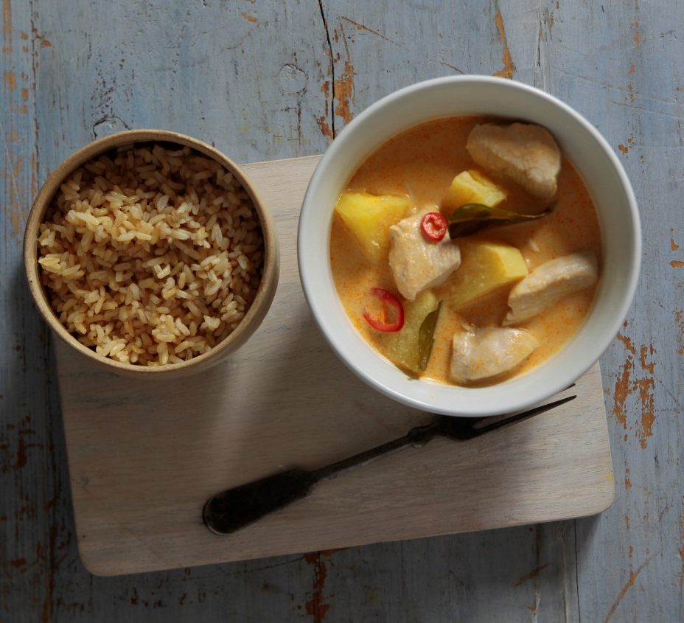
Serves 4-6

Ingredients
- 750g chicken breast or thigh, chopped
- 500ml coconut milk
- 1tbsp red curry paste
- ½ tsp fish sauce
- 3 kaffir lime leaves
- ½ fresh pineapple, diced
- 2 red chillies - sliced (seeds removed if required)
- 2 chicken stock cubes
- + Serve with brown rice and steamed vegetables

Method
- Pour coconut milk, fish sauce, curry paste and stock into pot and dissolve to creamy consistency.
- Bring curry to the boil over medium heat.
- Add chicken and continue to cook over medium heat for 5 mins.
- Add pineapple, kaffir lime leaves and chillis.
- Continue to cook over low-med heat for 15 min.

ENDS

View the interview video with Joanna McMillan:
http://mediagame-1.wistia.com/medias/ou01ux2o8z

INTERVIEWS, RECIPES AND HIGH RES IMAGES ARE AVAILABLE ON REQUEST

Please contact:
Ashley Mawer
IMPACT Communications
02 9519 5411 / +61 403 133 699
ashley@impactcommunications.com.au

About

The Australian Pineapples Family Nutrition Report was conducted by Galaxy Research in October 2012, who surveyed 510 main grocery buyers with children aged 18 years or under.

This project has been funded by HAL using the Pineapple industry marketing levy.

http://www.eatingdisorders.org.au/key-research-a-statistics / http://www.abc.net.au/local/stories/2009/02/17/2494060.htm

